**Practical No. 6**

**Q1. Storing Routes in Separate files.**

**Code:**

**routefile.js**

var express=require('express');

var router=express.Router();

router.get('/home', function(req, res){

res.send("Welcome from route Home...");

});

router.get('/login', function(req, res){

res.send("Welcome from route Login...");

});

module.exports=router;

**routefileimpl.js**

var express=require('express');

var app=express();

var route=require('./routefile.js');

app.use('/', route);

app.listen(3030);

console.log("Server Started...");

**Output:**



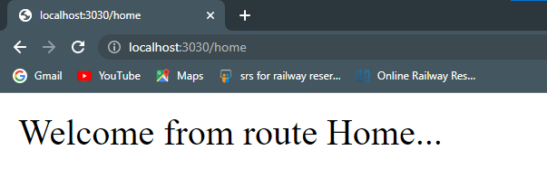

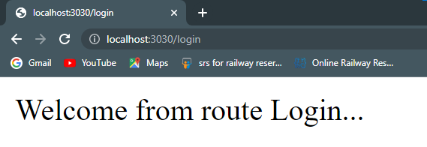

1. **Working with Express Middleware function**

**Code:**

var express=require('express');

var app=express();

app.get('/', function(req,res,ne){

res.send("Working with express middleware");

ne(logout());

});

function logout(req,res){

console.log("LOGOUT");

}

app.listen(3030);

console.log("Server Started...")

**Output:**



